**Project Planning Phase**

**Project Planning Template (Product Backlog, Sprint Planning, Stories, Story points)**

|  |  |
| --- | --- |
| Date | 15 November 2022 |
| Team ID | PNT2022TMID36315 |
| Project Name | Car Resale Value Prediction |
| Maximum Marks | 8 Marks |

**Product Backlog, Sprint Schedule, and Estimation (4 Marks)**

Use the below template to create product backlog and sprint schedule

|  |  |  |  |  |  |  |
| --- | --- | --- | --- | --- | --- | --- |
| **Sprint** | **Functional**  **Requirement (Epic)** | **User Story**  **Number** | **User Story / Task** | **Story Points** | **Priority** | **Team**  **Members** |
| Sprint-1 | Registration | USN-1 | As a user, I can enter into the website with the help of the Google chrome browser in Windows | 2 | High | 4 |
| Sprint-1 | Registration | USN-2 | As a user, I can enter into the website through browser in Android | 1 | High | 4 |
| Sprint-1 | Registration | USN-3 | As a user, I can enter into the website through browser in ios | 2 | Medium | 4 |
| Sprint-1 | Login | USN-4 | As a user, I can find the car resale value prediction page in the website | 1 | High | 4 |
| Sprint-2 | Home Page | USN-5 | As a user, I need to select the parameters like Year, Showroom price, Kilometres driven, fuel type etc and click on the submit button | 2 | High | 4 |
| Sprint-3 | Home Page | USN-6 | As a user, I can see the accurate price for car resale after entering the details. | 2 | High | 4 |
| Sprint-4 | Home Page | USN-7 | As a user, If I done a mistake while providing the details , I can reset the details and click the submit button. | 1 | Low | 4 |

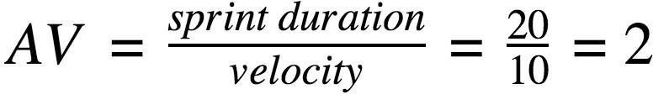**Project Tracker, Velocity & Burndown Chart: (4 Marks)**

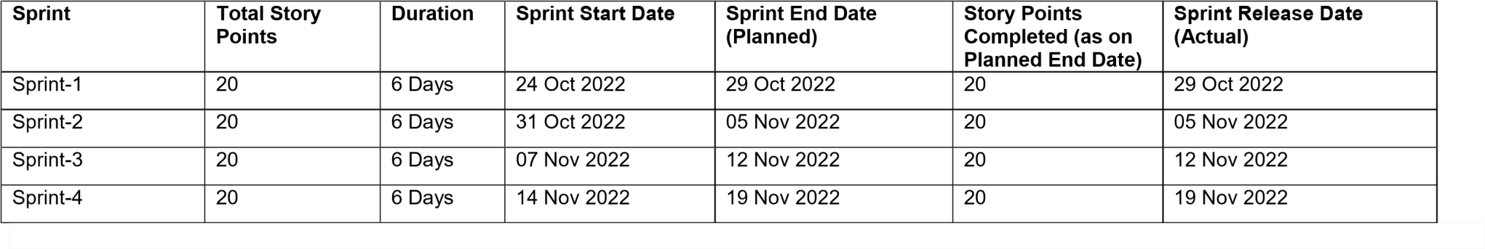

**Velocity:**

Imagine we have a 10-day sprint duration, and the velocity of the team is 20 (points per sprint). Let’s calculate the team’s average velocity (AV) per iteration unit (story points per day)

**Burndown Chart:**

A burn down chart is a graphical representation of work left to do versus time. It is often used in agile [software development m](https://www.visual-paradigm.com/scrum/what-is-agile-software-development/)ethodologies such as [Scrum. H](https://www.visual-paradigm.com/scrum/scrum-in-3-minutes/)owever, burn down charts can be applied to any project containing measurable progress over time.

